Wing/cockpit part -> span = 26 cm, length = 23 cm

1 cm

1 inch

Fuse parts / lateral profiles ->

CG area (approx), adjust with Lipo position

= to be reinforced (paint with CA or white glue, or fix thin plate of pleywood)

= lateral wing profiles (cut 2x)

= approx. Lipo position

= approx. Rx position

- 3 mm depron is well suited (“selitron”, I use cheapest insulation plates for roomwalls)

- print plan, enlarge on photocopy machine –> scale fits, if indicator bars (1cm/1inch) are correct
- mirror second wing half, tape both together as complete template for cutting the wing/cockpit part, cut prop openings in both wing halfs
- cut red fields for the pins of the upper fuse part going thru’ (as thick as your depron is)
- cut upper and lower fuse part
- cut green lateral wing profiles 2 x
- first glue (UHU-por) upper fuse part too wing area, form sigmoid profile carefully in (avoid breaking ..)
- then glue lower wing part too all from 6.
- carefully bend the sigmoid profile too the wings and glue green lateral profiles in
- cut out carefully the place for the lipo in the lower fuse part
- reinforce the mentioned areas on lower fuse and in the cockpi part of the wing
- let dry well, then bend some washout too the outer areas of the wings, that sigmoid profile is well
developed (see pics), install motors, RX and lipo.
- I reinforced also the front wing (leading edge) with some white glue for surviving crashes
- AUW of the plane without motors, RX and lipo should be ca. 4-5gr, AUW complete 17-19 gr.
- paint / draw as you like (I choose a “white B2 type” of the avro, for saving painting and weight ☺ )
- As drawing the plan with Word was fast and not so exact, some contours maybe refined – sorry for that : )
- I wish you lots of fun with this nice glider + turner, its easy too fly

-> See following some pics for a better understanding – my prototype looks a bit “wrecked” from a lot of flying in windy wheather. I have carved also some depron away, too get this nice bird as light as possible (here: 19gr). I will shurely build another one soon ! Its one of the best AA/xt flyers I know !

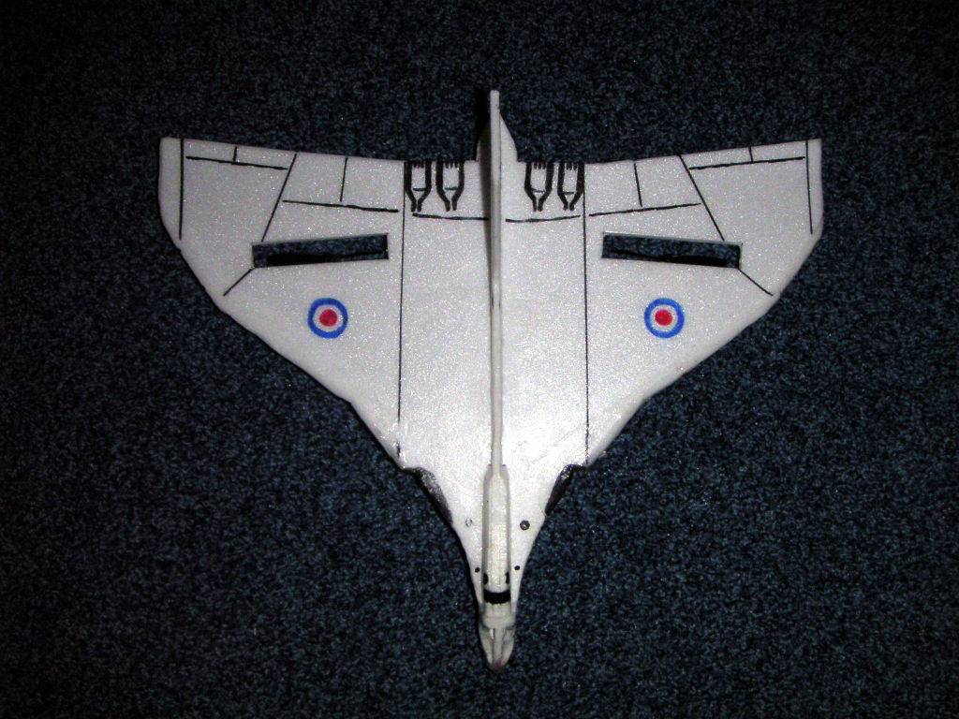
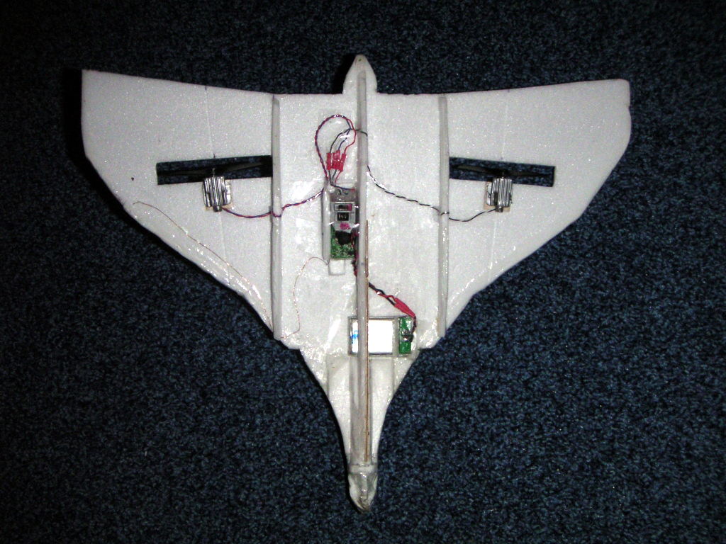
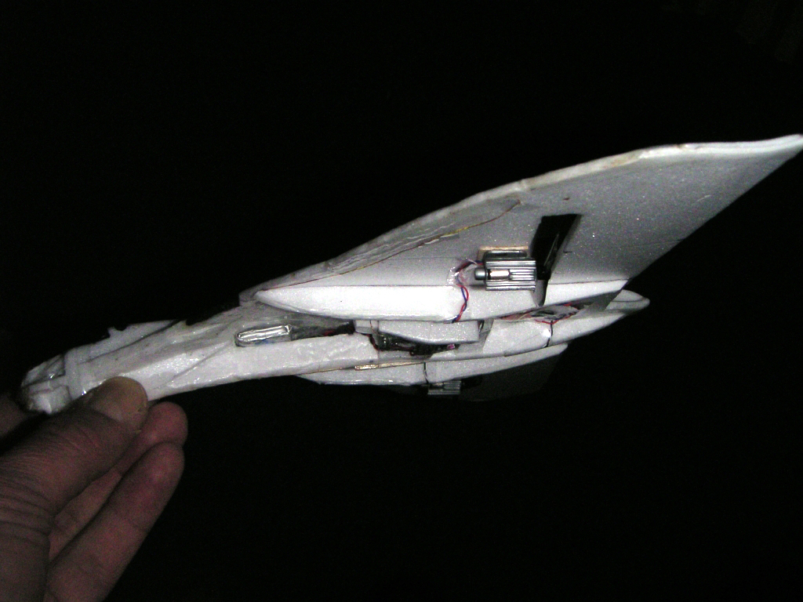
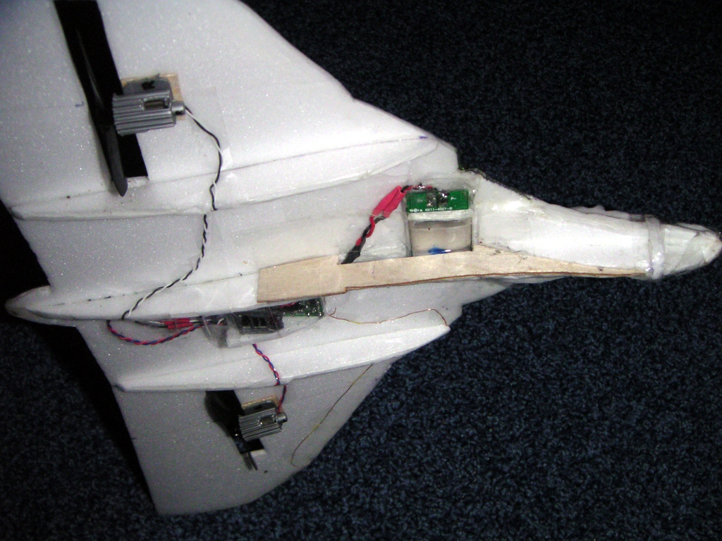

Relaxr - march 2006 (please only non-commercial hobby use) (page 7 of 7 – End of file)

